Image Export
Image Export is a tool for processing and geo-referencing aerial photography and image based maps for SurvCE.

Supported Image Types
Image Export supports GeoTIF, TIF, JPEG and BMP images.

Geo-referenced, GeoTIF, images are directly supported by reading the embedded tags in the image. TIFF, JPEG and BMP are supported with world files and the World File Editor.

File Menu
Open Image File
The Open Image File option will open and display an image file. You can select GeoTIF, TIFF, JPEG and BMP images. If the image is a GeoTIF the image coordinate positions will be displayed at the bottom of the image frame.

Save Image File
This option saves the image in the current format and original path and file name. If you save a GeoTIF image the geo-referencing tags will be lost.
Save as Image File
This option allows you to save the currently displayed image file to a new name and file format. If you save a GeoTIF image the geo-referencing tags will be lost.

Open Image Database
This option will open a currently existing image database. When an existing database is open new images will be appended to the database during processing.

Save Image Database
This option will save the processed images to the current or new database.

Image Properties
This option is used to display information on the current image.

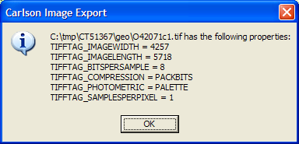

Tools Menu
Image Brightness
The Image Brightness tool is an easy way to make generalized adjustments to the tonal range of the image.

- Open an Image and choose Image Brightness from the Tools menu. The Image Brightness dialog box appears.
- Drag the slider to adjust the brightness of the image. Drag the slider to the left to decrease the brightness and to the right to increase it. Values range from -100 to +100.
- When you have finished making adjustments, click OK.

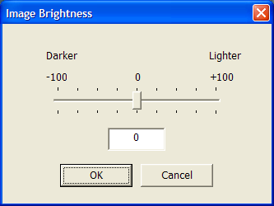

World File Editor
The World File Editor allows the user to import, view, create and edit image geo-reference information.
A world file is an ASCII text file used to geo-reference image files. World files have the following format.

World File Format
1.0 <X Resolution>
0.000 <Amount of Translation>*
0.000 <Amount of Rotation>
1.0 <Y Resolution>
424178 <X Coordinate of 1,1 (upper-left pixel)>
4313415 <Y Coordinate of 1,1 (upper-left pixel)>
Image Export supports the following World File Formats.
Image Format | World File
TIFF, TIF | TFW
JPEG, JPG | JGW
Bitmap, BMP | BPW

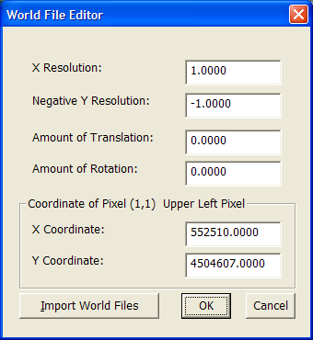

Image Viewer

Image Export has an image viewer to display the current image. Zoom level is controlled by the drop down list at the top left. GeoTIF images will display geographic coordinates in the bottom right panel. The X and Y pixel position is shown for all images.

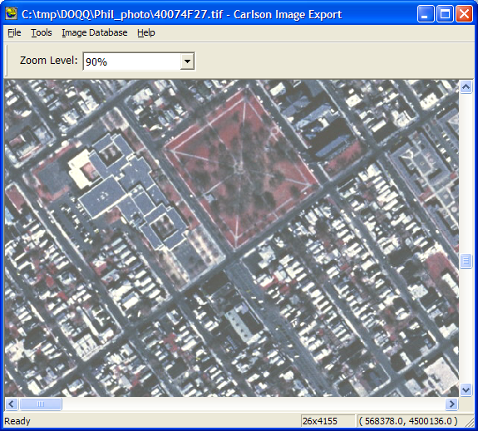
Image Database
Adding an Image to the Database
In order to display images in SurvCE they need to be added to the image database.
- Open an Image using Open Image File in the File Menu.
- Geo-reference the image. If the image is not a GeoTIF image use the World File Editor to geo-refence the image.
- Click Process to process and add this image to the image database. This process may take several minutes. The progress bar and dialog text will keep you informed of the progress. Large images are being clipped into smaller pieces for viewing in SurvCE. When complete click OK.
- Repeat the above steps to add multiple images to the database. Multiple images in the same database should be contiguous. Images from different locations should be placed in separate databases.
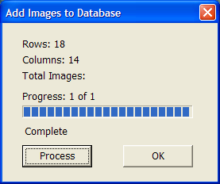
View Image Database
The View Image Database displays information for the images in the currently selected image database. The images processed are displayed in the top panel, and the sub images of the selected image are displayed in the bottom Panel.
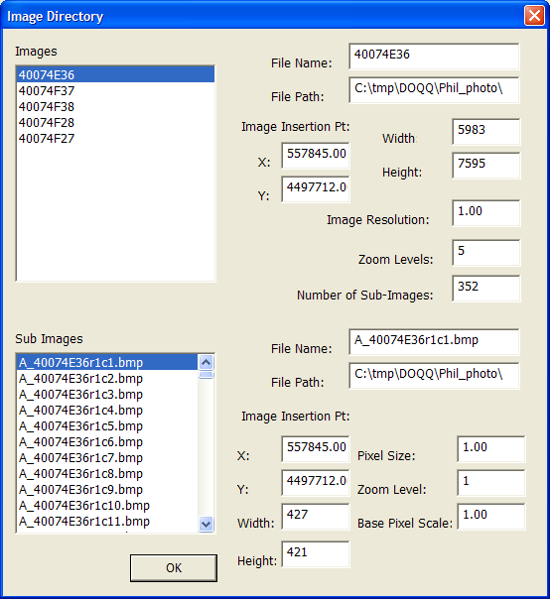
Save the Image Database
Use the Save Image Database command in the File menu to save the Image Database.
Open Image Database
Open an existing image database with the Open Image Database command in the File menu. When the database is open additional images can be appended to the database.

